The Ministry of Education and Science of the Republic of Kazakhstan

D. Serikbayev EKSTU

M. Mizernaya

ENVIRONMENTAL GEOLOGY

Methodical instruction for laboratory and practical classes

Major: 6D070600 - Geology and Exploration of Mineral Deposits

ЭКОЛОГИЧЕСКАЯ ГЕОЛОГИЯ

Методические указания для практических работ

Специальность 6D070600- Геология и разведка МПИ

Усть-Каменогорск
Ust-Kamenogorsk
2014
1 EARTH’S PLACE IN SPACE

  - Earth. Facing limited resources

Geospatially isolated in the universe. Origin of Earth system: Lithosphere (geosphere), atmosphere, hydrosphere, and biosphere. Facing limited resources: Energy, soil, freshwater, forests, ocean fisheries, rangelands Global environment: Dynamic conflicts and integrated resolutions.

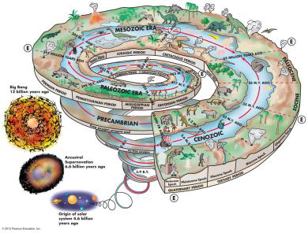

Figure 1- Earth History Inception: 4.6 billion yrs
James Hutton (1785): Earth as a superorganism …the oceans are the heart of Earth’s global system, and the forests are the lungs…
James Lovelock (1985) - Gaia hypothesis:
–Earth is an organism.
–Life significantly affects Earth’s environment.
–Life modifies the environment for the betterment of life.
–Life deliberately or consciously controls the global environment.
–Interdisciplinary thinking.
Environment: A complex system with physical, biological, geological, ecological, and geopolitical aspects.
Requires multidisciplinary research: Environmental geology, environmental chemistry, global climate change, biological diversity and ecosystems, environmental economics, environmental ethics, environmental law, etc.
Environmental crisis: Population, environmental hazards, resource limitations and contaminations, environment ownership (both in space and over time).
Geology:
–Study of processes related to the composition, structure, and history of Earth.
–Relies on chemistry, physics, and biology.
Environmental geology knowledge: applied geology:
–To better understand environmental problems.
–Geologic knowledge for problem solving.
–Minimize environmental degradation.
- Optimize the use of resources to maximize environmental benefits for the society.
Five fundamental concepts:
–Population growth.
–Sustainability – устойчивость.
–System and change.
–Hazardous Earth processes.
–Scientific knowledge and values.
Other concepts in environmental geology –Finite resources, health, obligation to future.

2 HUMAN POPULATION GROWTH

2.1 Number one environmental problem: Nearly 7 billion by the year 2010
“Population bomb?”
Exponential growth:
–Growth rate (G): Measured as a percentage.
–Doubling time (D): D = 70/G.
Above Earth’s comfortable carrying capacity: Implications to resources, land, waste .
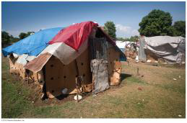
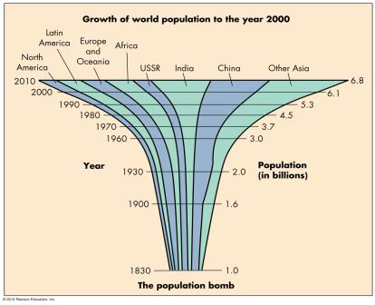

Figure 2- “Population bomb”

Uneven growing and distribution:
- By 2050, 3 billions more people;
- Almost all of the growth in developing countries;
No easy answer to the population problems;
Education is paramount, especially woman’s education. As people become more educated, the population growth rate tends to decrease.

2.2 Workshop1: questions for writing essay

1)Why is it important to monitor and potentially “control” population growth?
2) Why might population growth in the future be difficult to predict?
3) How does the number of people on this Earth affect your quality of life?
References:
- Arnott, R. (2004). Oil and gas reserves: communication with the financial sector. Paper on Sustainable.
- Development Programme SDP BP 04/02, Oxford Institute of Energy Studies.
- Kretzschmar, G.L., Misund, B., Hatherly, D. (2007). Market risk and oilfield ownership – refining.

3 SUSTAINABILITY. THE DEATH OF ARAL SEA

  - The environmental objective:
- An evolving concept.
- Expectation and reality.
Criteria variations in space and over time:
- Is a long-term concept and has long-term implications.
- Requiring careful resources allocation, large-scale development of new technology for resource use, recycling, and waste disposal.
- Measuring sustainability.
- Use and consumption of non-renewable resources.
- Natural replenishment and renewable rates Global consumption versus replenishment of resources.
- Development and improvement of human environment versus в viable environment.
- Doesn’t result in crisis.
3.2 Solving Environmental Problems. Difficult processes:
- Environmental problems tend to be complex.
- Rapid changes, slow recognition, slower actions.
- Some changes are of irreversible nature.
- Environmental policy links to environmental economics in infancy.

3.3 Workshop2: questions for case study «The Death of Aral Sea»:
- Once a prosperous vacation spot in 1960
- Water diversion for agriculture
- Dying sea surrounded by salt flats

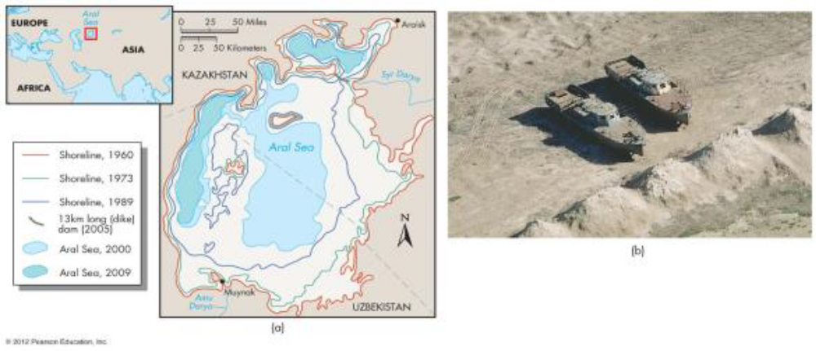

Biodiversity

Figure 3- “The Death of Aral Sea”
References:
- Markets and Portfolio Management, 21(2), 167–201.
- IMF (2007). Global financial stability report. World economic and financial surveys, October.
- Washington, DC: International Monetary Fund.
- IMF (2008). Global Financial Stability Report. World Economic and Financial Surveys, April.

4 BIODIVERSITY

  - What is an Ecosystem?

An ecological community and its surrounding environments in which the flows of energy and cycles of chemicals support the living community.
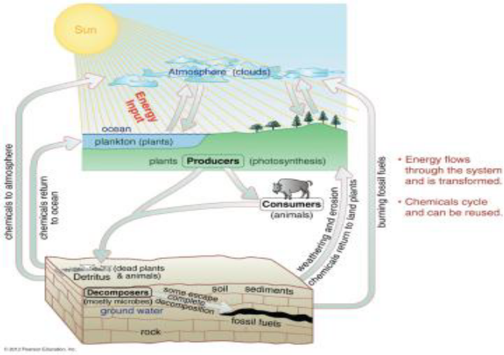

Figure 4- Ecosystem

Biodiversity- The number or abundance of species in an ecosystem or ecological community. Species richness: The number of species. Species evenness: Relative proportion of species.
Species dominance: One of multiple species more common than others
Keystone species: Exerting a stronger community effect disproportionate to their abundance.

4.2 Workshop 3: questions for case study

Keystone species: Species exert a strong community effects disproportionate to their abundance
Case study: Wolf, elk and mountain stream system in the Yellowstone National Park
–1960s–mid-1990s: Elk overgrazed the riparian vegetation, affected the stream ecosystem.
–Late 1990s: Reintroduced wolves that hunted elks and promoted the regrowth of riparian vegetation, water quality, and stream ecosystem.
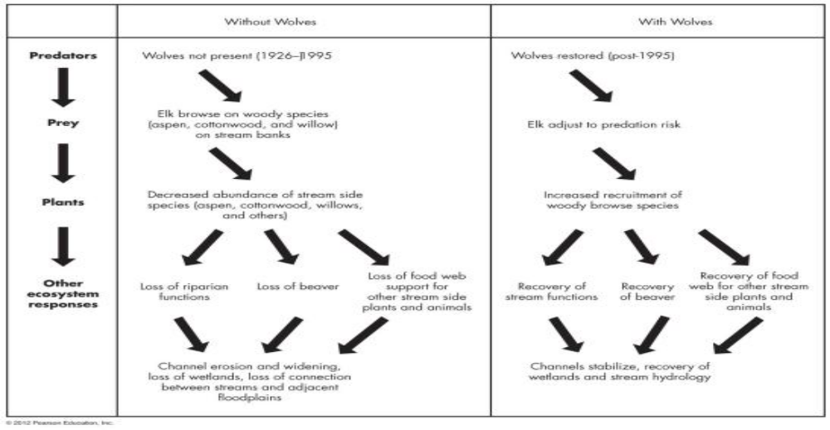

Figure 5- Wolf, elk n the Yellowstone National Park
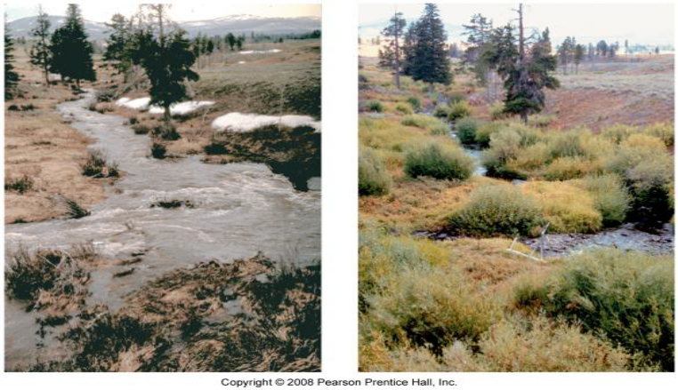

Figure 6- Wolf, elk and mountain stream system in the Yellowstone National Park
References:
- Montgomery. Environmental geology. McGraw-Hill/Mcgraw hill higher education. 2010/03/01

5 INTRODUCTION TO NATURAL HAZARDS

5.1 Criteria: A particular event in which 10 or more people are killed; one hundred or more people are affected; a declaration of emergency is issued, or there is a request for international assistance
Dangerous natural processes:
–Earthquakes
–Floods
–Volcanic activities
–Landslides
–Storms
Impact risks, depending on the nature of hazards, spatial and temporal relations to human environment

5.2 Types of Natural Hazards
Earthquakes, floods, cyclones (hurricanes) killed several million people, with an average worldwide annual loss of life of about 150,000 people. Annual average property damage exceeds $50 billion.
Why Natural Processes Become Hazards.
Natural processes become hazardous: When people live or work in areas where they occur.
–Population growth. Land-use changes, such as urbanization or deforestation, removal of wetlands.
–Environmental damages. Consumption of energy resources and climate changes (not just CO2).
Better environmental planning: DO NOT build on floodplains, earthquake prone areas
5.3 Hazard Magnitude and Frequency
Magnitude: Intensity of a natural hazard in terms of the amount of energy released
Frequency: Recurrence interval of a disastrous event…how often the event occurs
Magnitude and Frequency:
–Generally an inverse relation between them
–Largely controlled by natural factors
Low-magnitude and high-frequency hazards- not always destructive, a high-magnitude one almost certainly catastrophic

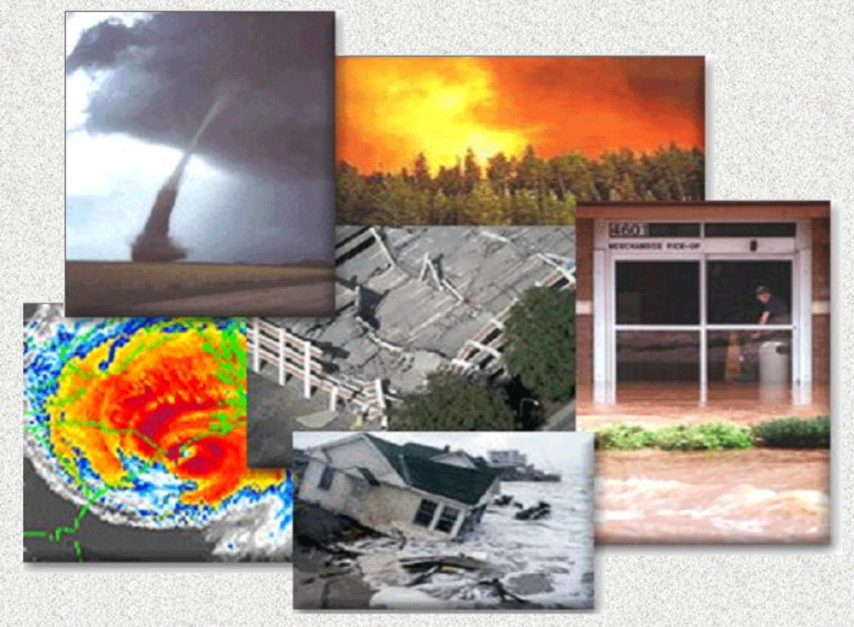

Figure 7- Types of Natural Hazards

5.4 Workshop 4: questions for case study
- Human Response to Hazards
- Global Climate and Hazards
- Population Growth and Natural Hazards
- Land-Use Change and Natural Hazards

6 EARTHQUAKE PROCESSES

6.1 Overview

Understand earthquakes, faulting, and estimation of magnitude
Know earthquake types, seismic risk, and major effects of earthquakes
Understand earthquake cycles and methods of prediction
Understand process of hazard reduction and perceived risk to humans

6.2 Case History: Earthquake

On January 12, 2010, a magnitude 7.0 earthquake struck Haiti and killed about 300,000 people
A magnitude 6.3 earthquake struck the midlevel town of L’Aqila in 2009, many of the buildings collapsed, killing about 300 people.
In Chili (February 27, 2010), a magnitude 8.8 earthquake, about 500 times as strong as the Haiti earthquake, killed about 800 people
Buildings are not designed to withstand shaking or are built improperly, causing far more deaths auses for Earthquakes
6.3 Earthquake: Sudden release of strain energy caused by rock rupture (through faulting)
–Brittle deformation
Earthquakes induced by human activities:
–Much smaller magnitude
–Reservoir-induced earthquakes
–Deep waste disposal and earthquake
–Nuclear explosions (underground testing)

6.4 Earthquake Magnitude
Focus: The point at depth where the rocks ruptured to produce the earthquake.
Epicenter: The location on the surface of Earth above the focus.
Moment magnitude: Measure of the energy released by the earthquake. Estimated by examining the records from seismographs. More appropriate for large EQs.
Richter magnitude: Describes the energy released by an earthquake. It is based upon the amplitude or size of the largest seismic wave produced by an earthquake.
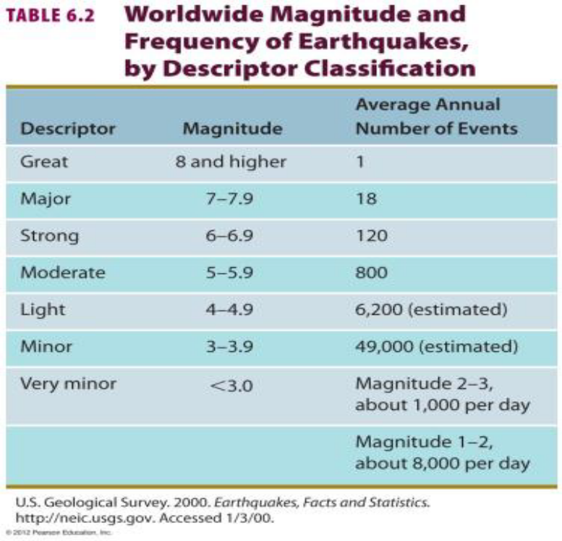

Figure 8- Earthquake Magnitude

6.5 Plate Boundary and Earthquakes. Most earthquakes concentrated along plate boundaries (nearly all catastrophic earthquakes are shallow earthquakes). Some interplate.
- Divergent plate boundary: Shallow earthquakes
- Transform plate boundary: Shallow to intermediate earthquakes
- Convergent plate boundary: Wide zone of shallow, intermediate, and deep earthquakes.
–~ 80% of seismic energy released along the earthquake zone around the Pacific rim.
6.6 Seismic Waves
Generated from the earthquake focus:
- P-waves: compression waves, travel faster through all physical states of media
- S-waves: shear waves, travel slower than P waves, but faster than surface waves, only propagate through solid materials
- Surface waves: moving along Earth’s surface, travel slowest, but cause most of the damage

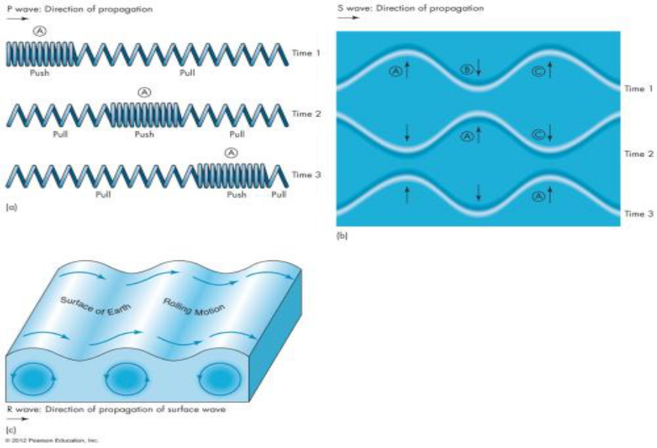

Figure 9- Seismic Waves

6.7 Effects of Earthquakes: Tsunami
Triggered by earthquake, submarine volcanic eruption, underwater landslide, asteroid impact
Recent tsunami examples:
–1883 Eruption of Krakatoa, 36,000 deaths
–1960 (M 9.5) Chile earthquake, 61 deaths in Hawaii
–1964 (M 9.2) Alaska earthquake, 130 deaths in AK/CA
–1993 (M 7.8) earthquake Japan, 120 deaths in Japan
–1998 (M 7.1) Papua New Guinea earthquake, 2100 deaths
–2004 (M 9.1) Indonesian earthquake, about 230,000 deaths
–2010 (M 8.8) Chile earthquake, about 20 coastal deaths
–2011 (M 9.0) Japan earthquake, about 15,700 deaths

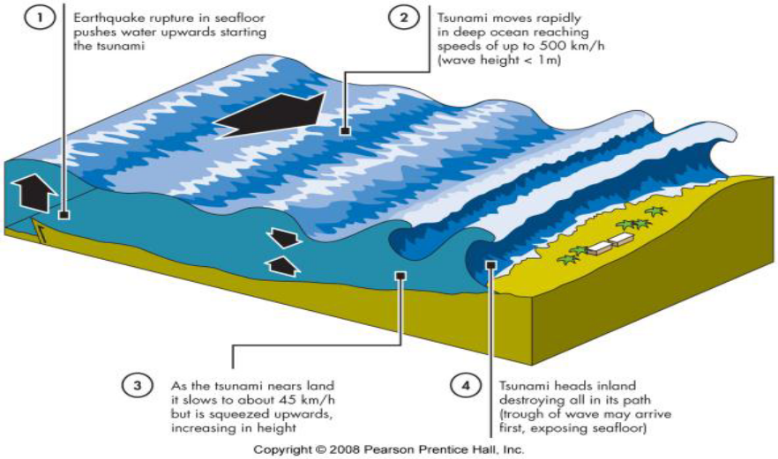

Figure 10 - Tsunami

6.8 Workshop 5: questions for case study

Perception of the Earthquake Hazard:
- Public education and preparedness for the earthquake potential, even psychologically
- Pre-earthquake planning: what to do when struck
- During-earthquake: understand the situation and formulate a good strategy
- Post-earthquake emergency response
- Better engineering structural designs to minimize the future hazard risks

7 VOLCANO TYPES. VOLCANIC IMPACT RISKS

7.1 Overview. Know the major volcano types, their rocks, and plate tectonic settings
Understand the effects of volcanic activity:
–Lava flows
–Pyroclastic activity
–Debris flows and mudflows (lahars)
Understand the methods of volcanic activity monitoring

7.2 Introduction to Volcanic Hazards
- ~ 1,500 active volcanoes on Earth
- 400 erupted in the last century
- ~ 50 eruptions per year
- Most activity concentrated along major plate boundaries
- Impact risks depend on the types of volcanoes
- ~ 500 million people living near volcanoes
- ~ 100,000 deaths during the last 125 years
- 23,000 lives lost in the last 20 years
- Densely populated countries in the volcanic zones include:
- –Japan, Mexico, Philippines, and Indonesia
- Some major cities (~ 350,000 people) located near volcanoes
7.3 Volcano Types:
- Shield, composite (stratovolcano), cinder cone
Volcanic eruption style
- Depending on lava’s viscosity and amount of dissolved gas (volatiles) content
- Viscosity: Liquid’s resistance to flow
- Determined by silica content (lava composition) and lava temperature
- Quiet flow (low viscous basalt flow) to violent explosion (high viscous lava eruption)
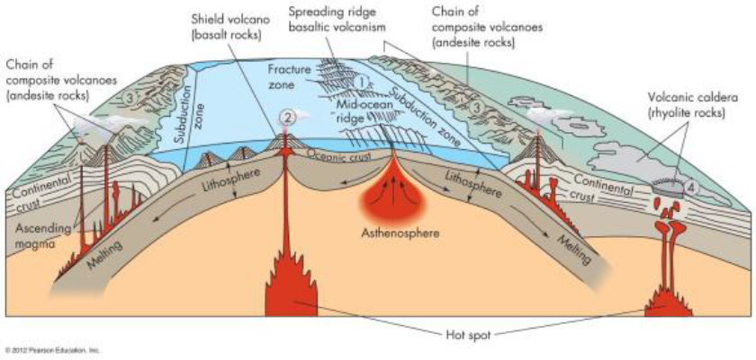

Figure 11 - Volcano Types

7.4 Workshop 6: questions for case study Public Perception and Adjustment
Perception of the volcanic hazards:
- Age and residence time affecting one’s perception
- No other choices as where to live
- Optimistic and accepting risks

Adjustment
- Public awareness and education
- Improvement in education
- Better scientific info dissemination
- Timely and orderly evacuation

8 STREAMS AND RIVERS

8.1 Overview
- Understand basic river processes.
- Understand the nature of the flood hazard.
- Understand the effects of urbanization on flooding in small drainage basins.
- Know the major adjustments to flooding and which are environmentally preferable.
- Know the potential adverse environmental effects of channelization and the benefits of channel restoration.
8.2 Case History: Pakistan Floods of 2010. The number of people killed or affected, along with economic loss, is the greatest in Asia .
A monsoon refers to a seasonal shift in air pressure and precipitation patterns (dry winter to wet summer). August of 2010, the greatest monsoon rains in decades, caused catastrophic flooding in Pakistan. July 29th, 12 inches of rain fell in the Upper Indus. Killed about 1,600 people, 20 million people were affected, 1.4 million acres were flooded.
Implications. The population of Pakistan has grown from about 34 million in 1951 to 170 million in 2010. Most people in Pakistan live close to the river. About 20 percent of Pakistan was flooded in 2010.
8.3 How to compare this catastrophe with the US:
Rethink our philosophy of how we adjust to the flood hazard in the United States as population grows.
Plans for future flood hazard reduction that do not require massive evacuation from flood prone areas.
–Avoid the hazard through land use instead of evacuation.

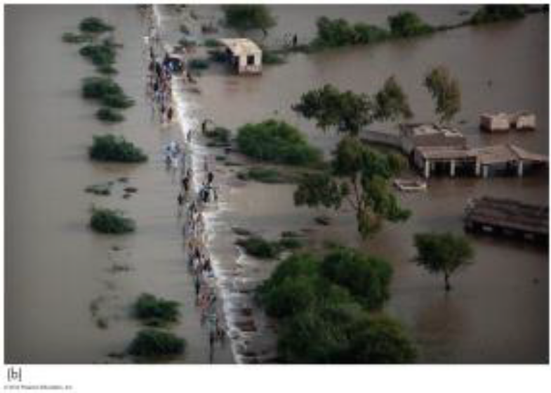

Figure 12 - Flood

Frequency and Magnitude of Flood. Recurrence interval:
R = (N + 1)/M … where N is the number of years of record, M is the rank of individual flow within the recorded years

The probability of a given magnitude flood:
P = 1/R
Statistical probability versus reality:
- Probability; one 25-year flood on average
- Reality; two 25-year floods consecutively

8.4 Types of Flooding
By stream location
–Upstream flood: Shorter duration, smaller area
–Downstream flood: Longer duration, greater magnitude, larger area
By duration
–Flash flood: High volume of flooding water in very short duration, characteristic short lag time, usually in upstream
–Non-flash flood
By magnitude/recurrence interval
–100-year, 50-year, 25-year, 10-year floods

8.5 Nature and Extent of Flood Hazard. Factors causing flood damage:
- Type of land use on the floodplain;
- Magnitude and frequency of flood;
- Rate and duration of flood;
- Season of the flood;
- Population density;
- Public awareness;
- Effectiveness of forecasting, warning, and emergency planning.

8.6 Effects of Flooding. Primary effects: Injury and loss of life, damage and destruction of property, erosion and deposition of sediments
Secondary effects - water pollution; fire;diseases; displacement of people; interruption of social and economic activities.
Adjustments to Flood Hazards.
1)Ffloodplain regulation: Obtaining the most beneficial use of floodplains:
–Flood-hazard mapping;
–Floodplain zoning.
2)Government buyout and relocating people from floodplain.
3)Personal adjustments.

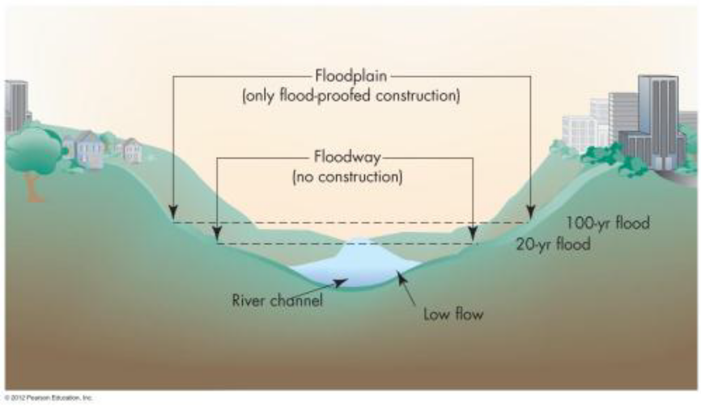

Figure 13 - Floodplain Zoning

Workshop 7: questions for case study Perception of Flooding.
1)Individual level: Variable in their knowledge of flooding, anticipation of future flooding, and willingness to accept adjustments.
2)Local and state level: Mitigation plans.
3)Federal government level.
–Mapping of flood-prone areas.
–Floodplain management plans.
–Public outreach.

9 WATER POLLUTION

9.1 Water and Ecosystems. Ecosystems: changes in response to climate, nutrient input, soils, and hydrology. General tendency: increased human use of water, increased degradation of natural ecosystems. Reconciliation between multiple water uses:
–Dams, reservoirs, canals – and associated impact on surface water environment.
–Reconcile uses of water – agriculture, industry, urbanization, and recreation.
–Protection of wetlands and water resources.
Overview:
- Define water pollution .
- Discuss some of the common water pollutants.
- Understand methods for groundwater pollution treatment .
- Understand important processes related to wastewater treatment and management.

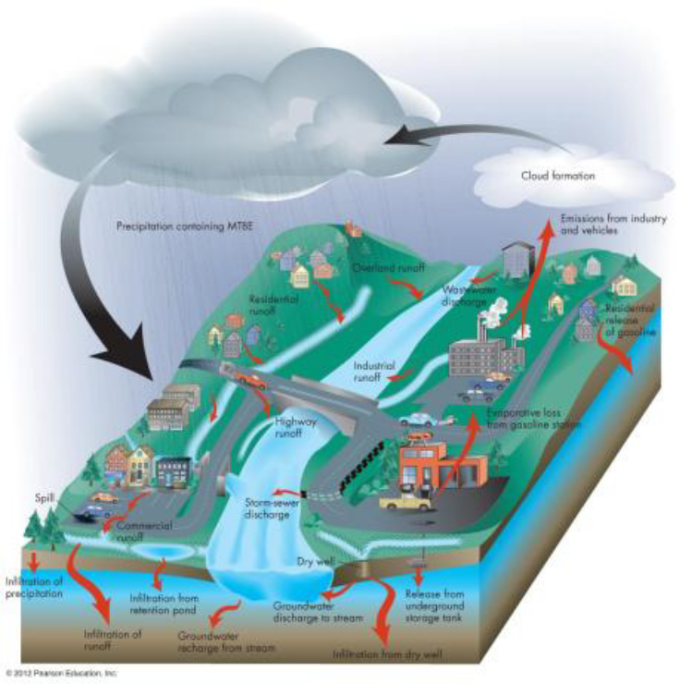

Figure 14 - Define water pollution
9.2 Workshop 8: questions for case study:Emerging Global Water Shortage
1)Global patterns of water shortage.
2)Depleted water resources: over-drafted aquifers, dried lakes (Aral Sea), troubled streams (Colorado and Yellow River).
3)Polluted, limited water resources due to development and increased wastes.
4)Demands for water resources tripled as population more than doubled in the last 50 yr.
5)Climate change…causing more problems.

10 MINERAL RESOURCES AND ENVIRONMENT

10.1 Overview
- Understand the relationship between human population and resource utilization
- Understand why minerals are so important to modern society
- Understand the difference between a resource and a reserve
- Know factors that control the availability of mineral resources
- Understand environmental impact of mineral development
- Know the potential benefits of biotechnology
- Understand the economic and environmental role of recycling mineral resources and sustainability
10.2 Case History: Mine Transformation. An award-winning golf course near Golden, Colorado, is now located on land where used to be an open-pit quarry for 100 years. The mine produced clay from layers between the limestone beds to make bricks. The bricks were used as a building material for buildings in the Denver area, including the Colorado governor’s mansion. Fossil Trace Golf Club: A unique instance of mine reclamation.
Minerals and Human Use: backbone of modern societies; availability of mineral resources as a measure of the wealth of a society; important in people’s daily life as well as in overall economy; processed materials from minerals accounting for 5 % of the U.S. GDP; mineral resources are nonrenewable.
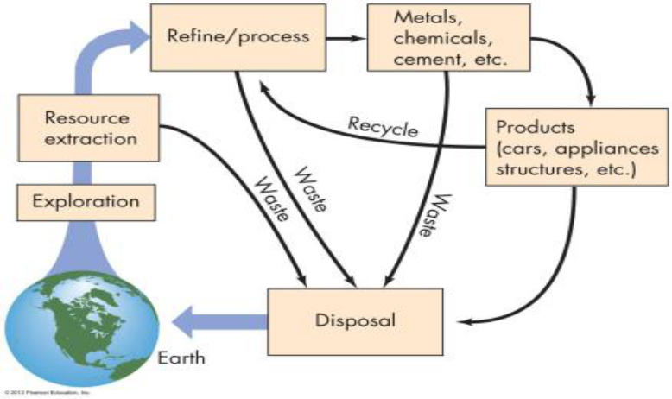

Figure 14 - Recycling Mineral Resources

10.3 Workshop 8: questions for case study: Minimizing the Impact of Mining.
1)Knowledge and technology transfer: Developed countries to developing countries.
2)Environmental regulations: forbid bad mining practices, Clean Air Act, and on- and offsite treatment of wastes.
3)Land reclamation: About 50 percent of land used in mining industry reclaimed.
4)Use of new biotechnology in mining: Bio-oxidation, bioleaching, biosorption, genetic engineering.
5)Practicing the three Rs of waste management.

11 ENERGY RESOURCES

11.1Overview

Understand peak oil and the impact to social and economic environment.
Know U.S. energy consumption. Know types of fuel or energy: fossil, nuclear, and geothermal. Know types of alternative, renewable energy. Know issues regarding energy policy and the concept of sustainable energy development.

11.2 Case History

Energy Transition 1800– Present:
- The amount of fossil fuels in the Earth is finite.
- Energy transformation in the United States from wood in the mid-1800s to fossil fuels in the mid-1900s.
Shortages of wood in 1812 in Philadelphia led to experiments of burning coal
–The first oil well was completed in 1858.
Peak oil production (when about one-half of Earth’s recoverable oil will have been produced and used) is likely to occur sometime between 2020 and 2050.
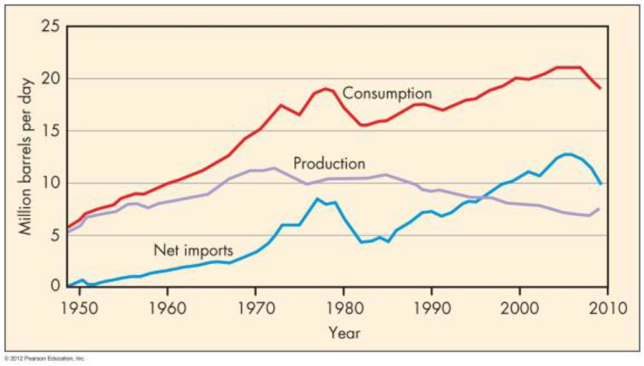
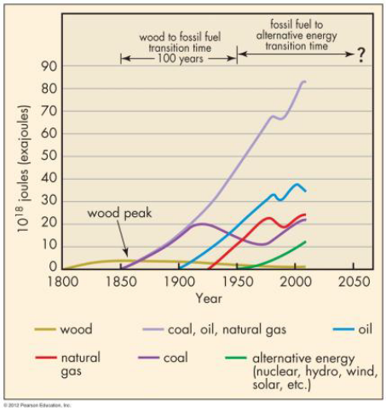

Figure 15 - Energy Transition 1800– Present

11.3 Critical Thinking Topics

- Sustainable energy development means an energy policy and energy sources without harming the environment. Do you think this is possible?
- Is it possible that new technology will be able to make fossil-fuel burning a clean process? Explain.
- Speculate the possibility of power plants in space .
- List specific actions that an individual citizen can take to conserve energy and reduce environmental impact.

12 SOILS AND ENVIRONMENT

12.1 Overview

- Understand soil terminology and the processes responsible for the development of soils.
- Understand soil fertility and the interactions of water in soil processes.
- Become familiar with soil classification.
- Know primary engineering properties of soils.
- Know relationships between land use and soils.
- Know sediment pollution and management.
- Understand how soils affect land-use planning, and how we can sustain soil resources .

12.2 Case History: Times Beach, MO

River town with pop. 2400, west of St. Louis. In 1983, the town evacuated and purchased by government for $36 million. Entire town contaminated with dioxin from the oil sprayed on the road to control dust. Dioxin: Composed of oxygen, hydrogen, carbon, and chlorine, extremely toxic to mammals and a carcinogen in humans; about 75 types of dioxin. Controversy concerning the effects of human exposure to dioxin, the evacuation an overreaction?

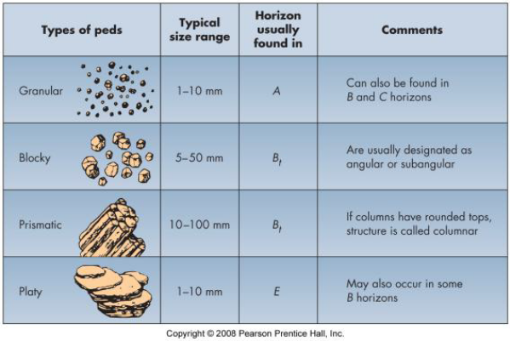
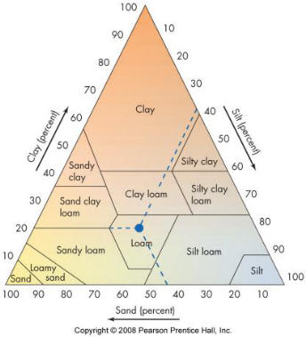

Figure 16 - Soil Texture and structure

Soil Survey and Land-Use Planning:
- Soil survey: Providing important information about soils.
- Soil properties: Critical for the best use of land; specific soils suitable for certain land use.
- Soil’s engineering properties: Necessary info for identifying potential problems before construction.
- Detailed soil maps: Helpful and important in land use planning.

13.3 Critical Thinking Topics

- Defend the statement that soil erosion is an environmental problem that could seriously damage, or even cause the collapse of, our civilization.
- What are things an individual citizen can do to prevent soil erosion?
- Does the impact of soil erosion go beyond where it occurs? Explain your answer.
- Are the soil problems more severe in developed countries or developing countries?

13 GLOBAL CLIMATE CHANGE

13.1 Overview

- Know the tools used for studying Earth system science and global change.
- Understand climate change and global warming.
- Know the important linkages associated with global change.
- Know some of the potential impacts of global warming and how they might be minimized.

13.2 Case History

Potential Consequences of Global Warming:
- Approximate 300 year period (1000 to 1300), Earth was considerably warmer than normal, known as the Medieval Warming Period (MWP).
- Followed by the Little Ice Age (LIA): Mid 1400 to 1700, difficult for people in Southeast Asia and Western Europe.
- Crop failures in Western Europe during the LIA, the population devastated by the Black Plague about 1400.
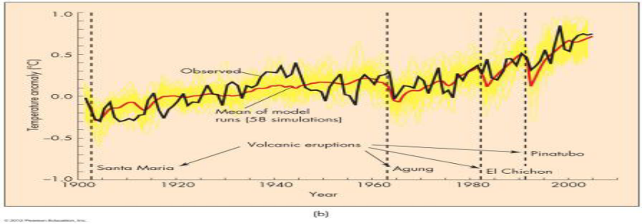

Figure 17 - Modeling the Climate

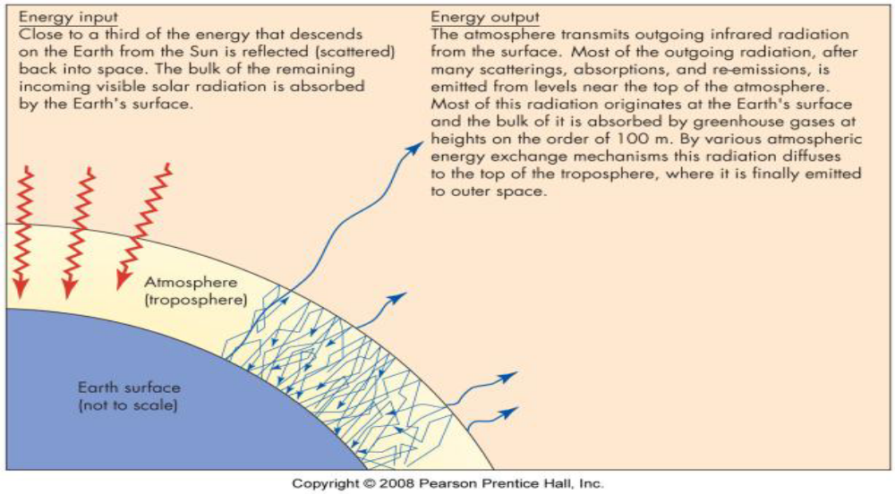

Figure 18 - Reducing the Impact of Global Warming

13.3 Reducing the Impact of Global Warming

Reducing the Impact of Global Warming:
- Identify historic changes that have occurred.
- Predict the potential changes in the future.
- Reduce greenhouse gases.
- Political commitment: reconciling the conflicts between the environmental need for reduction of greenhouse gases and the economic demands for more fossil fuel.
Reduce CO2 levels in atmosphere:
- Improved engineering technologies of fuel-burning power plants.
- Use fossil fuels releasing less CO2 .
- Conservation of energy.
- Store CO2 in forests, soils and rocks, depleted oil and gas fields, saltwater aquifers (sequestration of CO2).
- Use alternative, renewable sources of energy.

The Kyoto Protocol, international agreement to reduce emissions of greenhouse gases, signed by 166 nations, became formal international treaty in 2/05.
Even if carbon emissions were reduced to zero, warming will continue this century.
There is 0.5° to 1.0°C warming in the system.

Coupling of Global Change Processes – Negative Forcing:
- The coupling of the greenhouse and ozone depletion problems from CFCs.
- Burning of fossil fuels and acid rain problems.
- Use of fossil fuels and volcanic eruption problems and atmospheric cooling.

13.4 Critical Thinking Topics

- Have a discussion with your parents or grandparents and write down the major changes that have occurred in their lifetime as well as yours.
- Rapid economic development in developing countries occurs at the expense of environment. Should people put environment issues first? Why or why not?
- Will new technologies be part of solution on problems in global warming? Explain.
- What are the major ways to reduce emission of CO2?

14 GEOLOGY, SOCIETY, AND THE FUTURE

14.1 Overview

- Know geologic aspects of environmental health.
- Understand the geologist’s role in evaluating land for appropriate uses.
- Understand environmental impact analysis.
- Know the process of law; the use of mediation and negotiation to solve environmental conflicts.
- Be able to discuss what steps are necessary to attain the goal of sustainability.

14.2 Case History Radon Gas: The Stanley Watrus Story

In December of 1984, scientists discovered that radon (a radioactive gas) from soil and rock may enter the home and possibly present a serious health hazard. Stanley Watras lived in Boyertown, PA, the radiation level of the indoor air at his house was 3,200 pCi/l, 800 times higher than the level of 4 pCi/l, a threshold set by the EPA. Held the highest record in early 1980s, until a home in Whispering Hills, New Jersey, reached a radiation level of 3,500 pCi/l. Increased awareness of the radon gas problem in the United States since 1985.

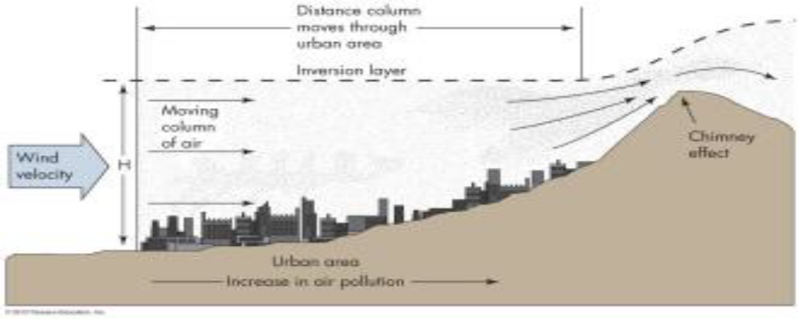

Figure 19 - Urban Air Pollution

14.3 Critical Thinking Topics

- For the region in which you live, identify potential hazardous wastes that are produced by homes, businesses, and industry or agriculture
- Do you think the steps stated by Lester Brown are necessary to avoid an environmental crisis?
- Discuss how an environmental crisis in China would affect the global environment. What could China do to avoid some of the environmental damages of industrial growth?
- What are the critical relationships between geology, environment, and the future?

REFERENCE

1.Bell F.G. A Environmental geology PDF Second edition. Elsevier Linacre House, Jordan Hill, Oxford OX2 8DP, UK, 30 Corporate Drive, Suite 400, Burlington, MA 01803, USA, 2007. 593 p. ISBN-13: 978-0-7506-8077-6; ISBN-10: 0-7506-8077-6
- Klimchouk, A.B.. Hypogene Speleogenesis: Hydrogeological and Morphogenetic Perspective. Special Paper no.1, National Cave and Karst Research Institute, 2007 Carlsbad, NM, 106 pp.
- Peng S. , Zhang J. , Engineering Geology for Underground Rocks. Издательство:Springer. Год: 2007. ISBN: 3540732942.
- Price David George. Engineering geology - principles and practice PDF ISBN: 978-3-540-29249-4 Library of Congress Control Number: 2008937486 © 2009 Springer-Verlag.
- Montgomery. Environmental geology. McGraw-Hill/Mcgraw hill higher education. 2010/03/01
- G. Nelson Eby Principles of environmental geochemistry ISBN: 955-3-678-39249-3 Library of Congress Control Number
- Gunter Faure Principles and applications of geochemistry. Elsevier Linacre House, Jordan Hill, Oxford OX2 8DP, UK, 30 Corporate Drive, Suite 400, Burlington

Extra

- Денисов Н.Я. Инженерная геология и гидрогеология.- М.: Госстройиздат,2004.
- Ланге О.К. Основы геологии .-Изд. Моск. Унив.,2001.-224 с.
- Earth:An Introduction to Physical Geology: International Edition, Tarbuck Edward,
Pearson Education/Pearson education (us)
4. Economic Geology Pohl Walter L Wiley-Blackwell, 05.04.2011, 680, 9781444336634

